Sam-ba upload procedure

Version 1.1
For more information, contact Cyrille@hp.com

First, you need to install the sam-ba software (install_at91-ISP_v1.10.exe) and then the patch ().samba_26_patch-sam7l.zip (The patch needs to be unzipped in the \ATMEL Corporation\AT91-ISP v1.10\SAM-BA v2.6\lib Directory created while installing the first file).

The, you need to have the board connected to the PC serial port (we will assume com1 in this document).

To download, you will need to have the HP12C+.bin file in the sam-ba directory (where the sam-ba.exe file is located).

Programming a new board (manual procedure)
Assuming that you are using a never programmed before CPU, the procedure is as follow:
1) Power up the board (3V)
2) Press the Reset button (on the cable if using a cable, on the board if possible, or on the jig if using a jig).
3) Press the calculator ON button
4) Start Sam-Ba and select the following options:
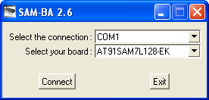
5) Click on connect
6) Select the Flash tab and select the HP12C+.bin file in the “send file name” edit.
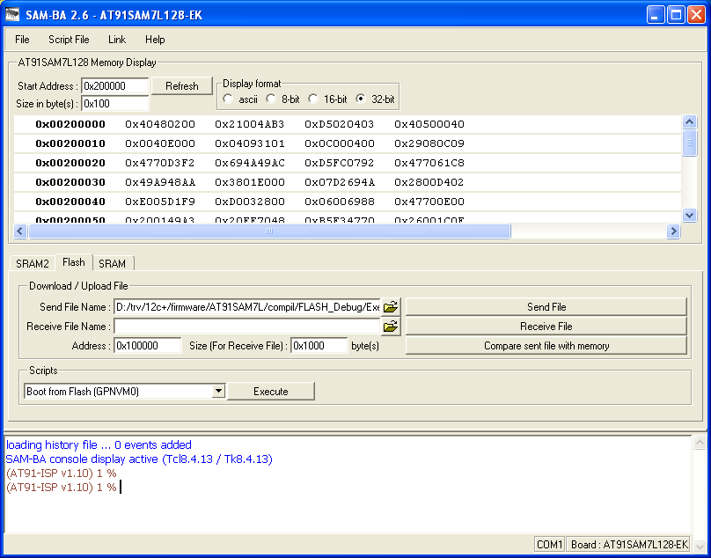

7) Press Send File
8) test file by pressing compare file with memory.

9) Press NO on the following dialog box


10) Then select the “Boot from Flash (GPNVM0)” script (see blue arrow above) and then execute. It will timeout and give an error, but that is ok.

11) On the board, press Reset followed by the ON key and the software should start.

The board is now programmed!

Programming a new board (automatic procedure)

Create a file “prog.tcl” in the Sam-ba installation directory (where the sam-ba.exe file is located) that contains the following 3 lines:

send_file {Flash} "HP12C+.bin" 0x100000 0
compare_file {Flash} "HP12C+.bin" 0x100000 0
FLASH::ScriptGPNMV 1

Create a file prog.bat that contains :
@echo on
sam-ba.exe COM1 AT91SAM7L128-EK prog.tcl > logfile.log 2>&1
type logfile.log

Assuming that you are using a never programmed before CPU, the procedure is as follow:
1) Power up the board (3V)
2) Press the Reset button (on the cable if using a cable, on the board if possible, or on the jig if using a jig).
3) Press the calculator ON button
4) On the PC, use the following command line: prog.bat (from the proper sam-ba directory) the following output should appear:

sam-ba.exe COM1 AT91SAM7L128-EK prog.tcl > logfile.log 2>&1 type logfile.log
-I- Waiting ...
connection : COM1
board : AT91SAM7L128-EK
target(handle) : 18563296
read chip ID : 0x00000000 at addr: 0xFFFFEE40
read chip ID : 0x27330740 at addr: 0xFFFFF240
-I- Found processor : AT91SAM7L128 (0x27330740)
script file : prog.tcl
-I- Send File HP12C+.bin at address 0x100000
-I- File size = 24404 byte(s)
-I- Compare File : HP12C+.bin with memory at address : 0x100000 , for 24404 byte(s)
-I- Read File FiletempPcMonitor.testCompare at address 0x100000
Sent file & Memory area content (address: 0x100000, size: 24404 bytes) match exactly !
-I- Boot from Flash selected

If anything else appear (especially a dialog box (processor ID not found), or the memory content does not match (last line), you need to re-program the board

5) On the board, press Reset followed by the ON key and the software should start.

Programming time is around 10s per board (testing not included)

Reprogramming a board
If you have a board that is already programmed, you will need to erase the flash by inserting the following procedure before step 2:
- Press and hold the Erase key on the jig or cable.
- Press the Reset key on the jig or cable
- Press the On Key on the calculator
- Release the Erase key on the Jig or cable

